**Getting started with AWS**

[AWS Cloud Computing Zero to Hero](https://letsupgrade.in/my-programs/LAWSEJUL121)

[LetsUpgrade](https://letsupgrade.in/)

**ASSIGNMENT 03**

* **Creating an Environment**

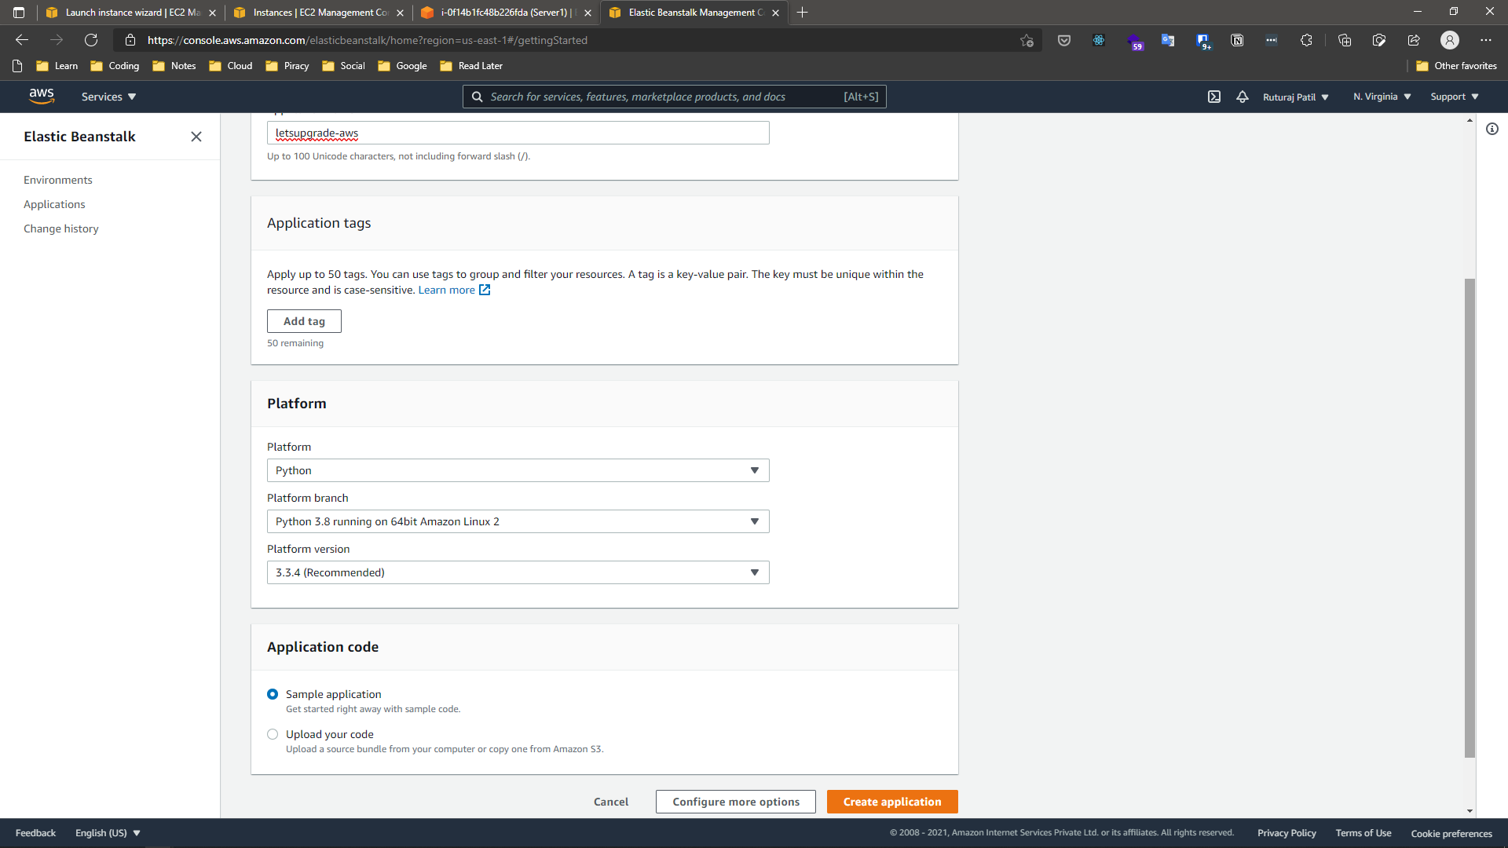

* **Environment Created**

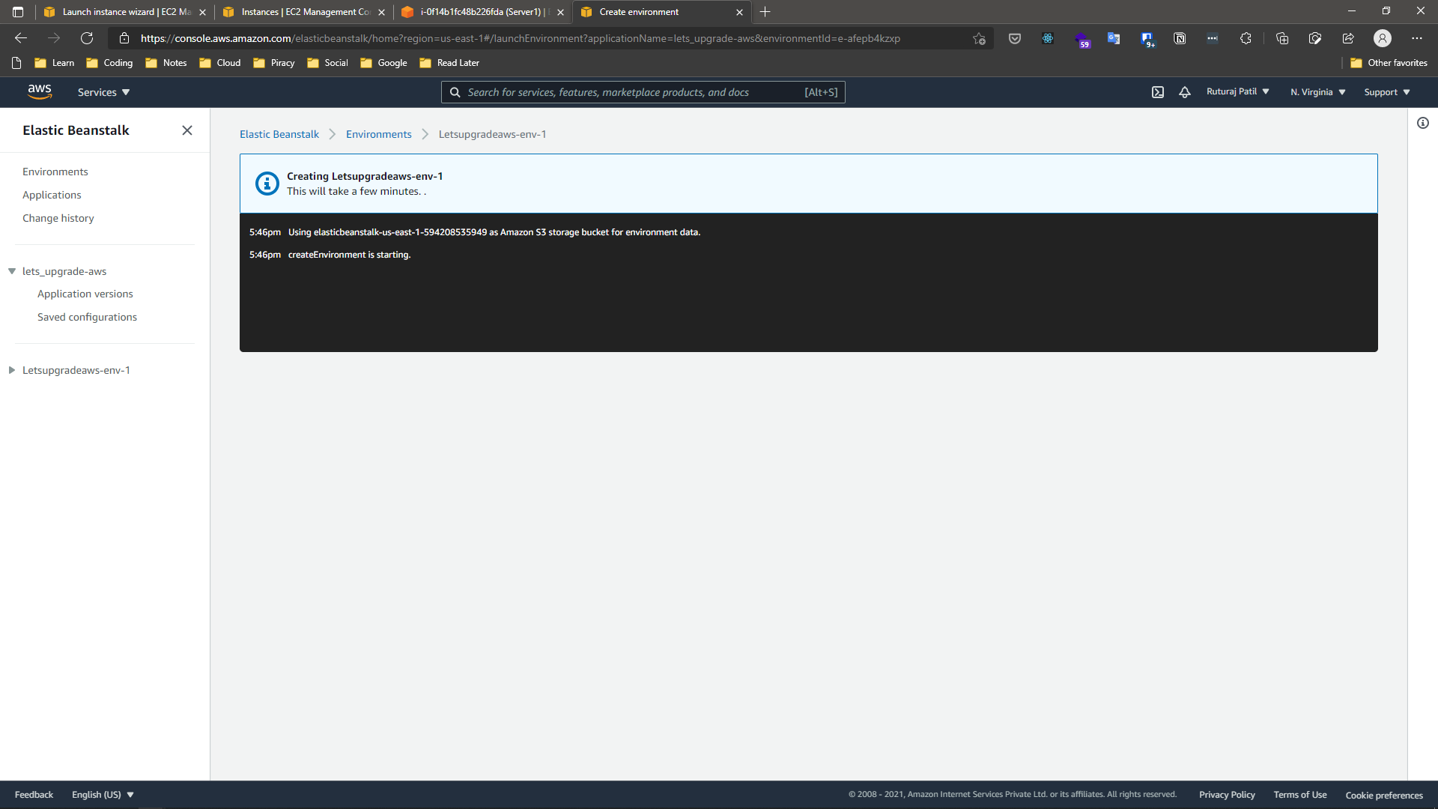

* **Events**

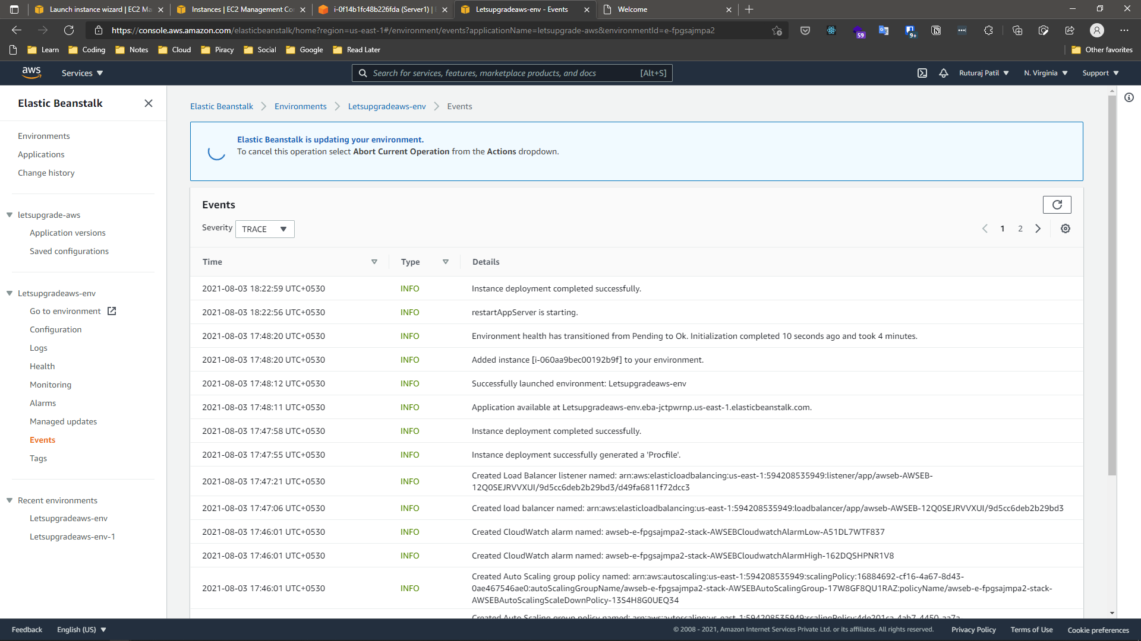

* **Environment URLs**

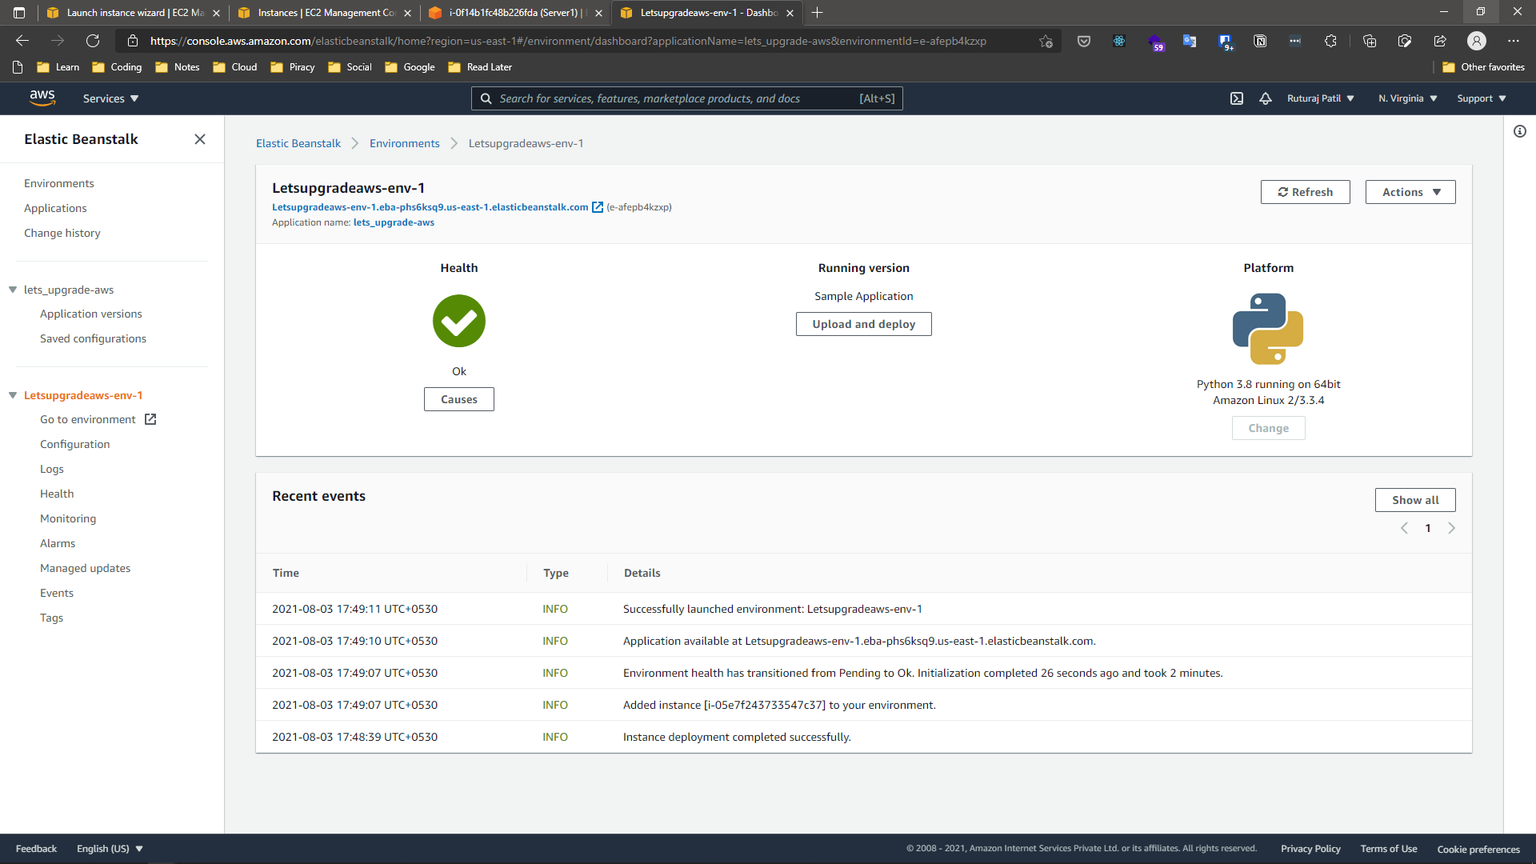

* **Application Version**

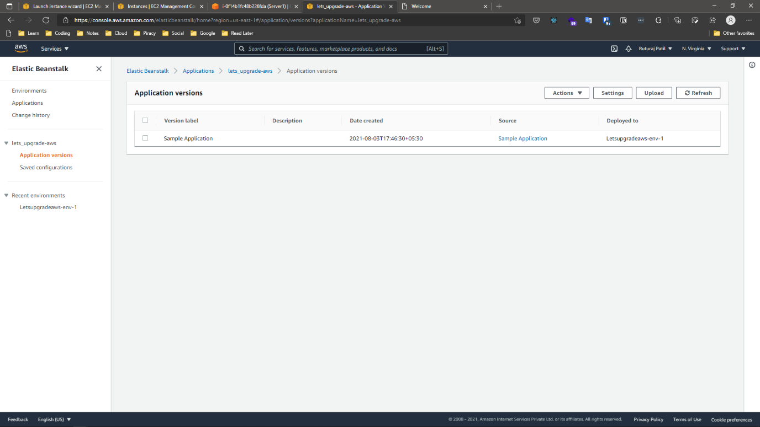

* **Environment**

